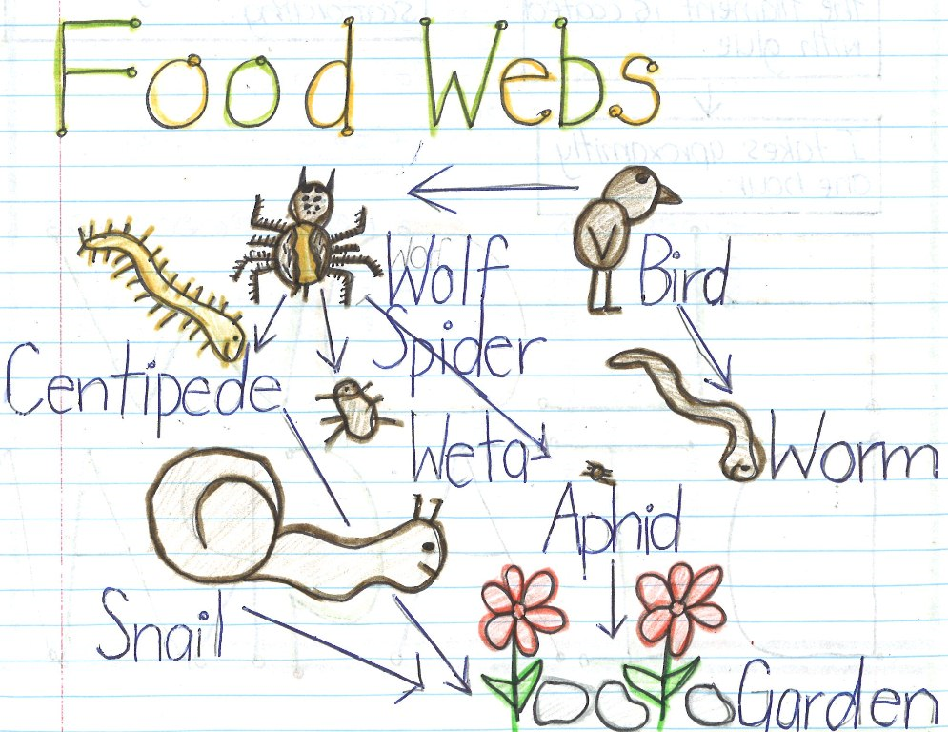

Compare: If a question asks you to ‘compare’ one thing with another then you are being asked to show how the two things are similar and also how they are different. In your answer you need to include at least one similarity and at least one difference.

1. Write some things that food chains have or do ___________________
____________________________________________________________________________________________________________________________________________________________________________________________________________________________________________________

2. Write some things that food webs have or do ___________________
____________________________________________________________________________________________________________________________________________________________________________________________________________________________________________________

3. Now compare the two. ______________________________________
_________________________________________________________________________________________________________________________________________________________________________________________________________________________________________________________________________________________________________________





